Crypto Settlement
# Source: AI Source: Provided by: [Data Path: Persons Table -> ID Column: 1, Name_En Column: Motasem Essam] -> From: [ChatGPT] on [1/21/2026]
A Crypto Settlement Network is a decentralized payment infrastructure where funds are transferred and settled using blockchain technology instead of traditional banks. It allows instant, peer-to-peer settlements in cryptocurrencies without needing a central authority like a bank or card network.

🧠 Simple Definition
# Source: AI Source: Provided by: [Data Path: Persons Table -> ID Column: 1, Name_En Column: Motasem Essam] -> From: [ChatGPT] on [1/21/2026]
A crypto settlement network uses blockchain or distributed ledger technology (DLT) to move digital assets directly between wallets, with built-in finality, transparency, and security.

🔗 How Crypto Settlement Works
# Source: AI Source: Provided by: [Data Path: Persons Table -> ID Column: 1, Name_En Column: Motasem Essam] -> From: [ChatGPT] on [1/21/2026]
- User A initiates a payment in cryptocurrency (e.g., Bitcoin, USDT).
- The transaction is broadcasted to the blockchain network.
- Nodes validate and confirm the transaction (via mining or staking).
- Once confirmed, the transaction is final and settled — funds are transferred.
- The recipient sees the updated balance in their crypto wallet.

💱 Examples of Crypto Settlement Networks
# Source: AI Source: Provided by: [Data Path: Persons Table -> ID Column: 1, Name_En Column: Motasem Essam] -> From: [ChatGPT] on [1/21/2026]
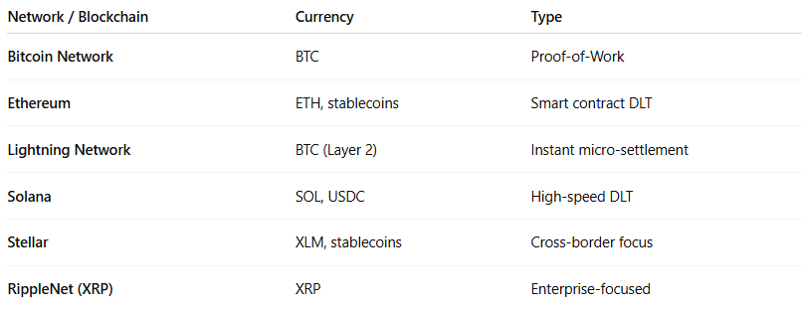

Network / Blockchain | Currency | Type
Bitcoin Network | BTC | Proof-of-Work
Ethereum | ETH, stablecoins | Smart contract DLT
Lightning Network | BTC (Layer 2) | Instant micro-settlement
Solana | SOL, USDC | High-speed DLT
Stellar | XLM, stablecoins | Cross-border focus
RippleNet (XRP) | XRP | Enterprise-focused

🔐 What Makes Crypto Settlement Unique
# Source: AI Source: Provided by: [Data Path: Persons Table -> ID Column: 1, Name_En Column: Motasem Essam] -> From: [ChatGPT] on [1/21/2026]
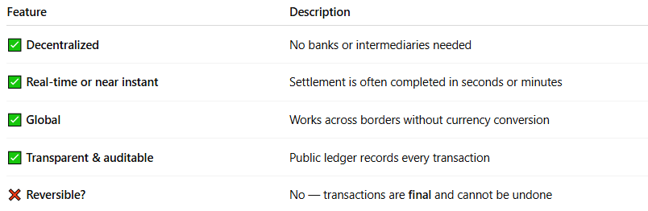

Feature | Description
✅ Decentralized | No banks or intermediaries needed
✅ Real-time or near instant | Settlement is often completed in seconds or minutes
✅ Global | Works across borders without currency conversion
✅ Transparent & auditable | Public ledger records every transaction
❌ Reversible? | No — transactions are final and cannot be undone

📊 Types of Crypto Settlement
# Source: AI Source: Provided by: [Data Path: Persons Table -> ID Column: 1, Name_En Column: Motasem Essam] -> From: [ChatGPT] on [1/21/2026]
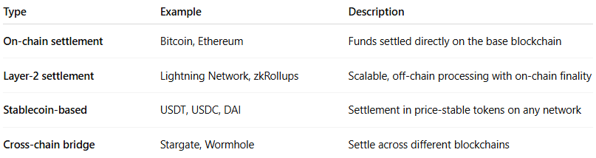

Type | Example | Description
On-chain settlement | Bitcoin, Ethereum | Funds settled directly on the base blockchain
Layer-2 settlement | Lightning Network, zkRollups | Scalable, off-chain processing with on-chain finality
Stablecoin-based | USDT, USDC, DAI | Settlement in price-stable tokens on any network
Cross-chain bridge | Stargate, Wormhole | Settle across different blockchains

💸 When Is Crypto Settlement Used?
# Source: AI Source: Provided by: [Data Path: Persons Table -> ID Column: 1, Name_En Column: Motasem Essam] -> From: [ChatGPT] on [1/21/2026]
- Cross-border payments
- Merchant crypto payments (e.g., BitPay, Binance Pay)
- Decentralized finance (DeFi) applications
- Peer-to-peer transfers
- Tokenized asset exchanges (NFTs, securities)

⚖️ Crypto vs Traditional Settlement Networks
# Source: AI Source: Provided by: [Data Path: Persons Table -> ID Column: 1, Name_En Column: Motasem Essam] -> From: [ChatGPT] on [1/21/2026]
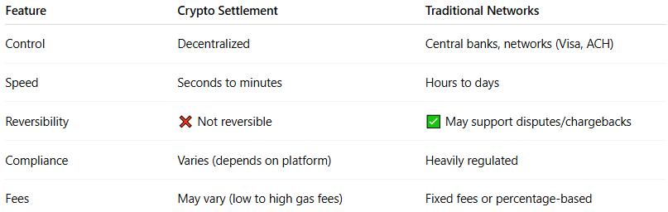

Feature | Crypto Settlement | Traditional Networks
Control | Decentralized | Central banks, networks (Visa, ACH)
Speed | Seconds to minutes | Hours to days
Reversibility | ❌ Not reversible | ✅ May support disputes/chargebacks
Compliance | Varies (depends on platform) | Heavily regulated
Fees | May vary (low to high gas fees) | Fixed fees or percentage-based

🧠 Summary
# Source: AI Source: Provided by: [Data Path: Persons Table -> ID Column: 1, Name_En Column: Motasem Essam] -> From: [ChatGPT] on [1/21/2026]
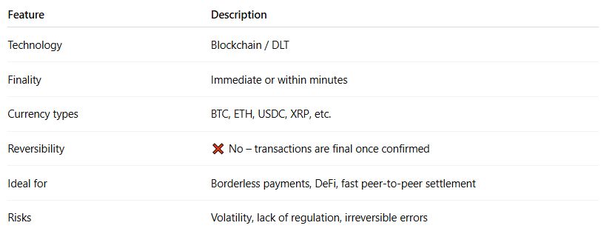

Feature | Description
Technology | Blockchain / DLT
Finality | Immediate or within minutes
Currency types | BTC, ETH, USDC, XRP, etc.
Reversibility | ❌ No – transactions are final once confirmed
Ideal for | Borderless payments, DeFi, fast peer-to-peer settlement
Risks | Volatility, lack of regulation, irreversible errors

Would you like a comparison chart showing when to use crypto vs card vs mobile settlement in real-world apps?

